WOMENS CHRISTIAN COLLEGE, NAGERCOIL
DEPARTMENT OF COMMERCE
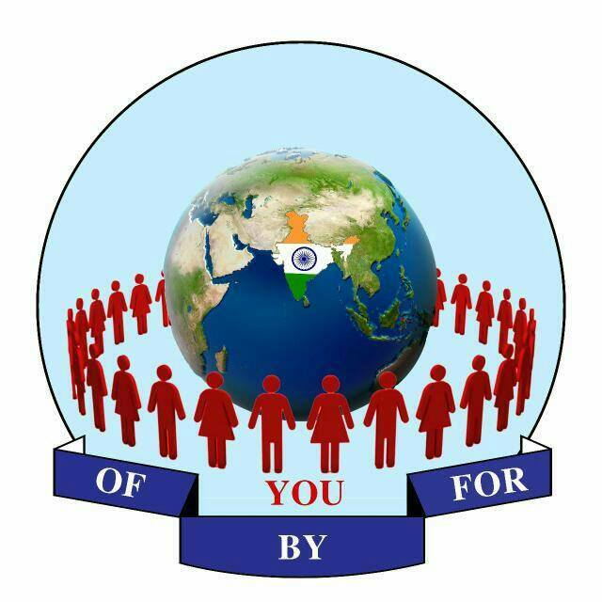

Organises

SEMINAR
ON
ENTREPRENEURSHIP

07.02.2020

NEED OF THE SEMINAR
The seminar entitled “Entrepreneurship” is to create entrepreneurs. Entrepreneurs take the economy and the society to the state of progress and prosperity. Entrepreneurship is the dynamic process of creating incremental wealth and innovating things of value that have a bearing on the welfare of an entrepreneur. It provides civilization with an enormous amount of goods and services and enhances the growth of social welfare. The main importance of entrepreneurship is the creation of job opportunities, innovation, and improvement of the economy. New products and services created by entrepreneurs can produce a cascading effect, where it stimulates related businesses or sectors that need to support the new venture, furthering economic development.

WHO CAN PARTICIPATE
UG AND PG students of Arts and Science stream

REGISTRATION FEE
Rs.50/- for each participants
(Registration fee includes Refreshment and Certificates only)

CONTENT OF THE SEMINAR
Who is an Entrepreneur?
How to become an Entrepreneur?


Guidelines for “Young Entrepreneurs Award Program”

CONDUCTED BY

CAPE RESEARCH FORUM
OF, BY AND FOR – YOU TRUST
Trust.Reg.No.198/ B4 - 2017
Nagercoil, Kanyakumari Dist.
For Registration Contact:

Dr.Sheela
86103 11546



